qbittorrent password set
1. sudo docker logs qbittorrent

2.In left panel go to Categories - All - right click and 'add category':

movies

tv

music

--------------

Default Save Path: - set to /data/torrents

Management Mode - Automatic

Tick BOTH BOXES for Use Subcategories and Use Category paths in Manual Mode

---------------
Prowlarr:
http://<host_ip>:9696

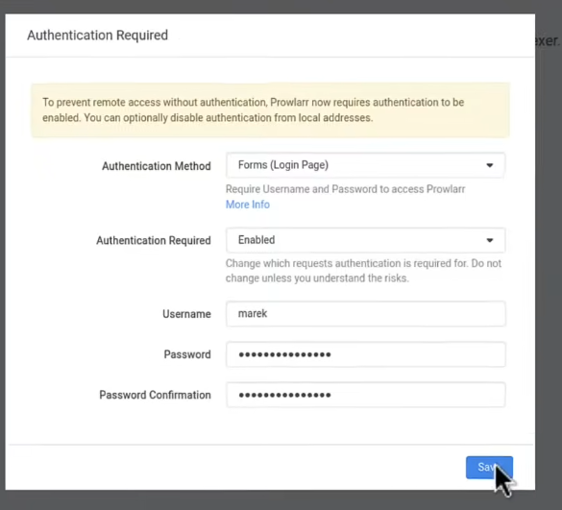

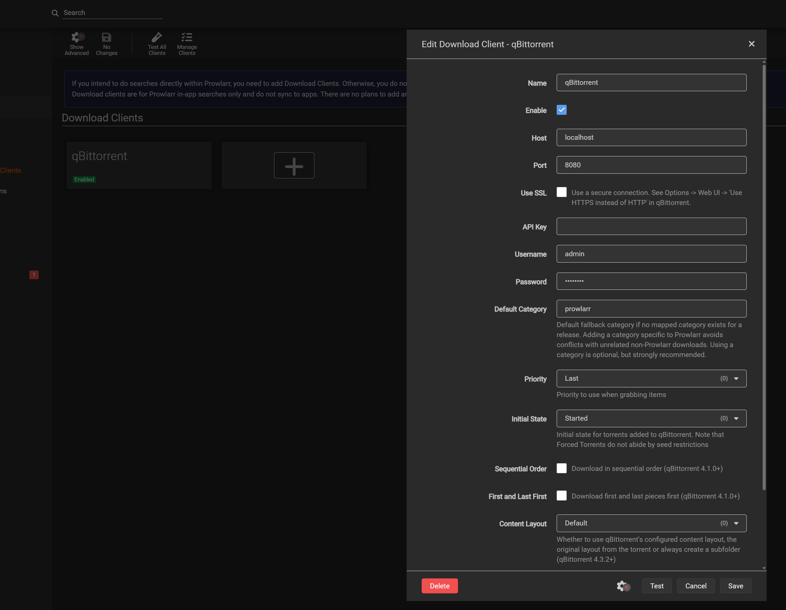

Radarr:

http://<host_ip>:7878

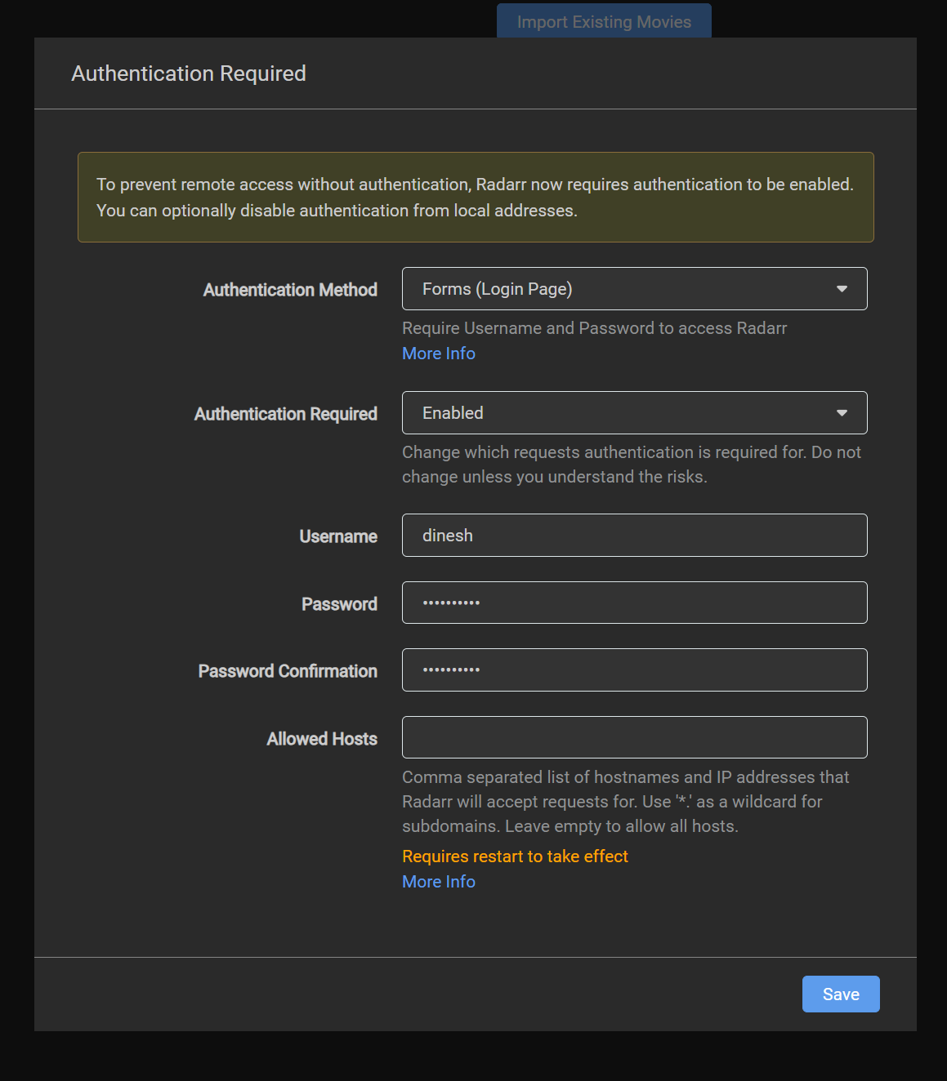

Go to Settings - Media Management - Add Root Folder (scroll down to the bottom) - set /data/media/movies as your root folder
Still in Settings - Media Management - click Show Advanced - Importing - Use Hardlinks instead of Copy - make sure its 'ticked'

Optional - you can also tick Rename Movies and

Delete empty movie folders during disk scan ,

and in Import Extra Files - make sure that box is ticked
and in Import Extra files field type srt,sub,nfo (those 3 changes are all optional)

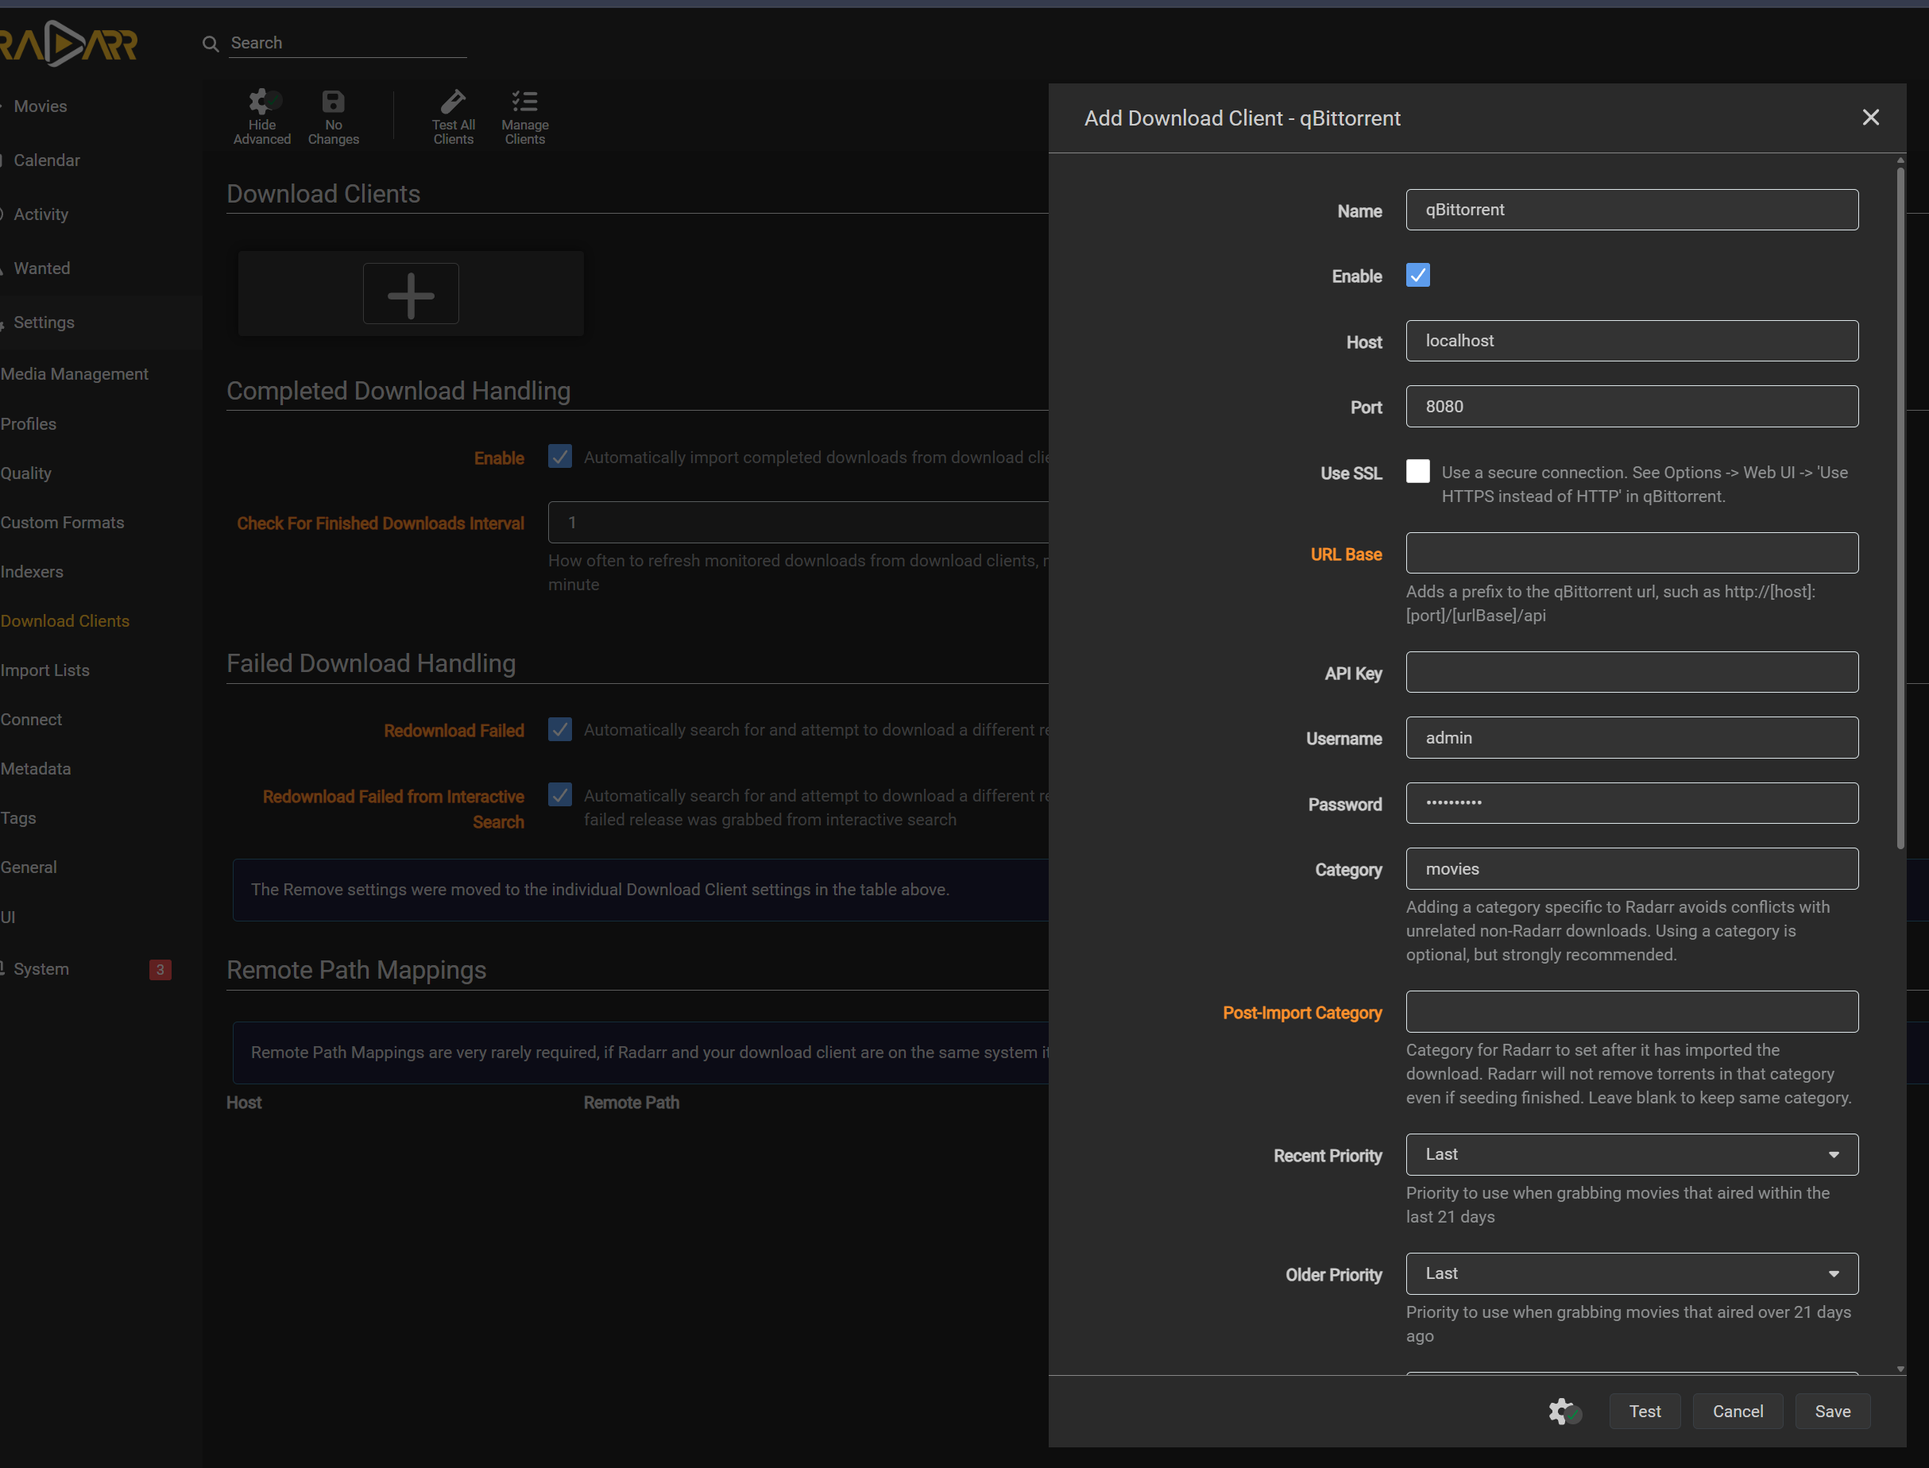

Radarr > Now go to Settings - General - scroll down to API key - Copy API key - go back to Prowlarr - Settings - Apps -click + - Radarr - paste API key.
